2023_SKCET_Cloud_ CIA1

727721EUIT045

HARIHARAN PL

Q3.Create an IAM group called ‘EC2-Admins’ with ‘AmazonEC2FullAccess’ and ‘AutoScalingFullAccess’ policies,then add an IAM user called as ‘EC2Admin1’.

1.The name of the IAM group should be ‘EC2-Admins’.

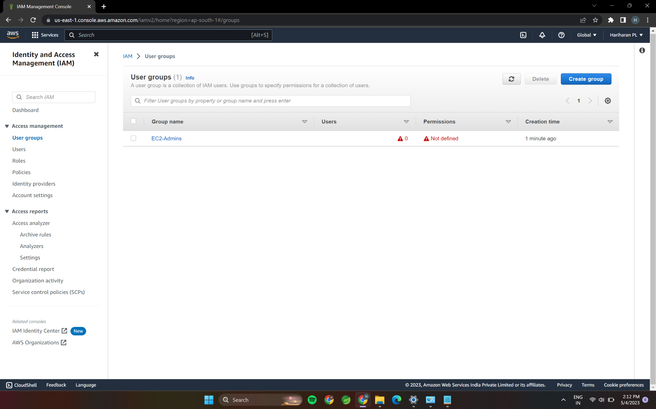

2.The name of the IAM user should be ‘EC2Admin1’

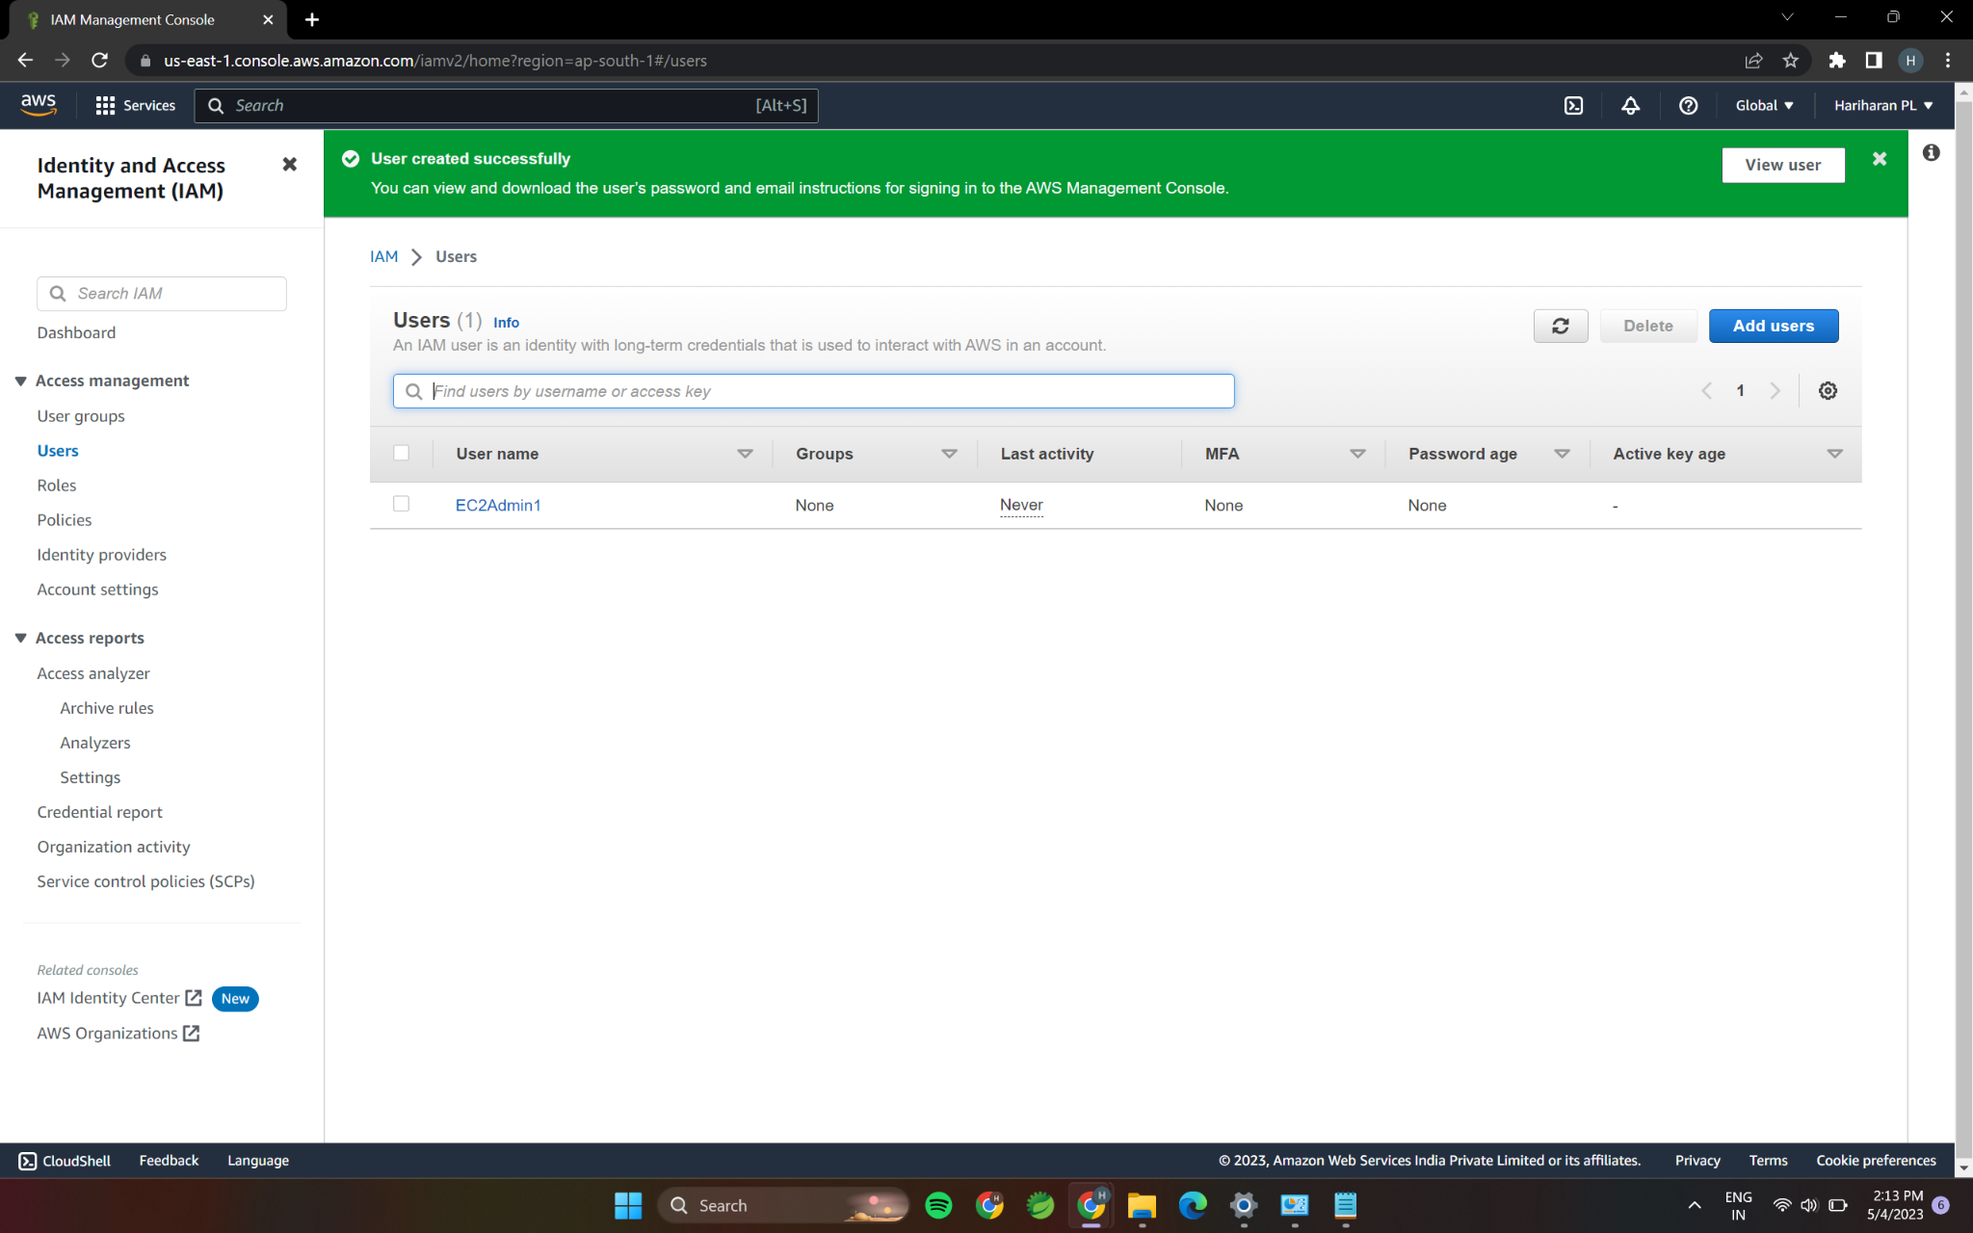

3.The AmazonEC2FullAccess’ policy should be attached.

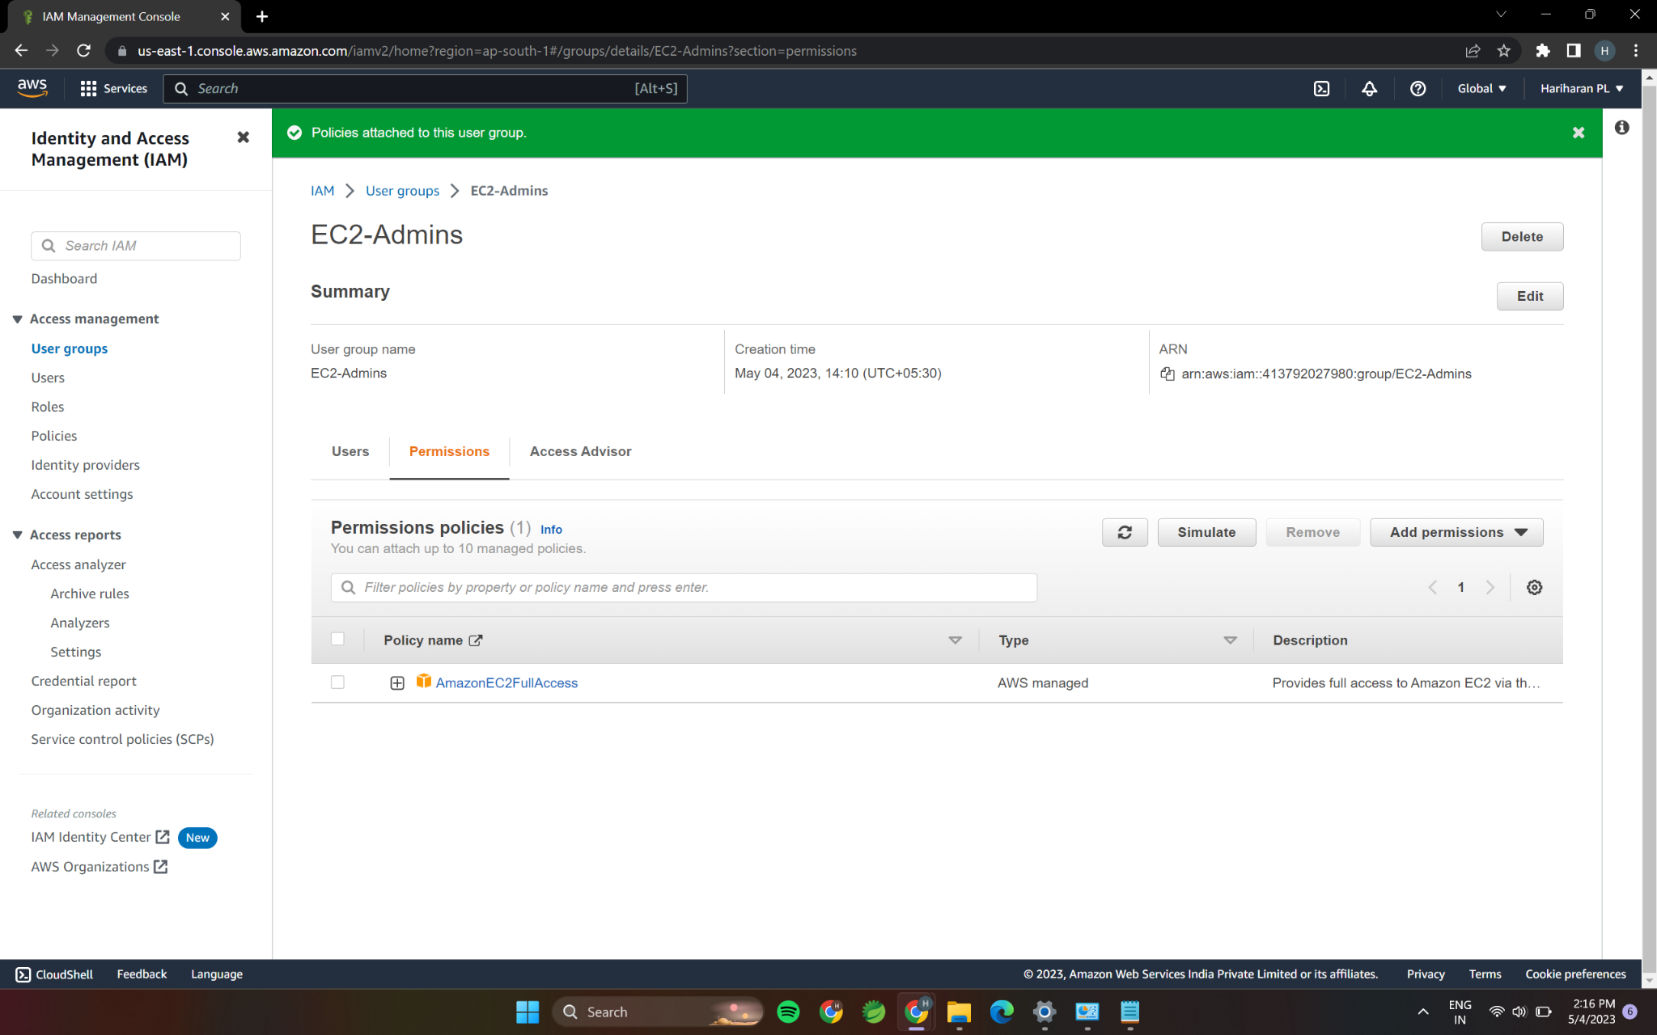

4.The ‘AutoScalingFullAccess’ policy should be attached.

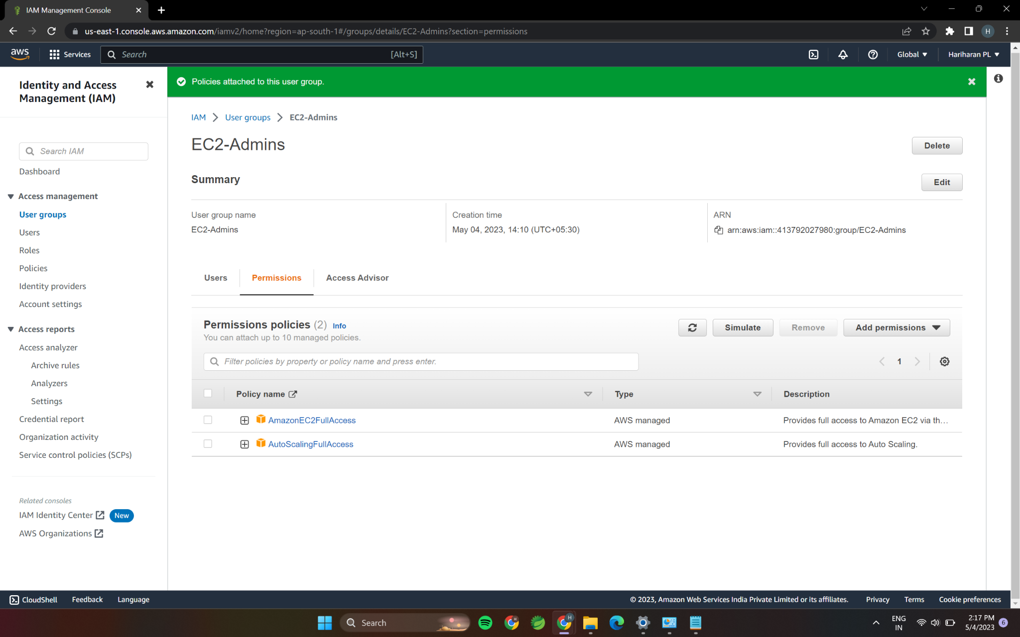

Q1.Create an EC2 instance with the following requirements.

1.Give the Name tag of both server & keypair as “ec2usecase2”.

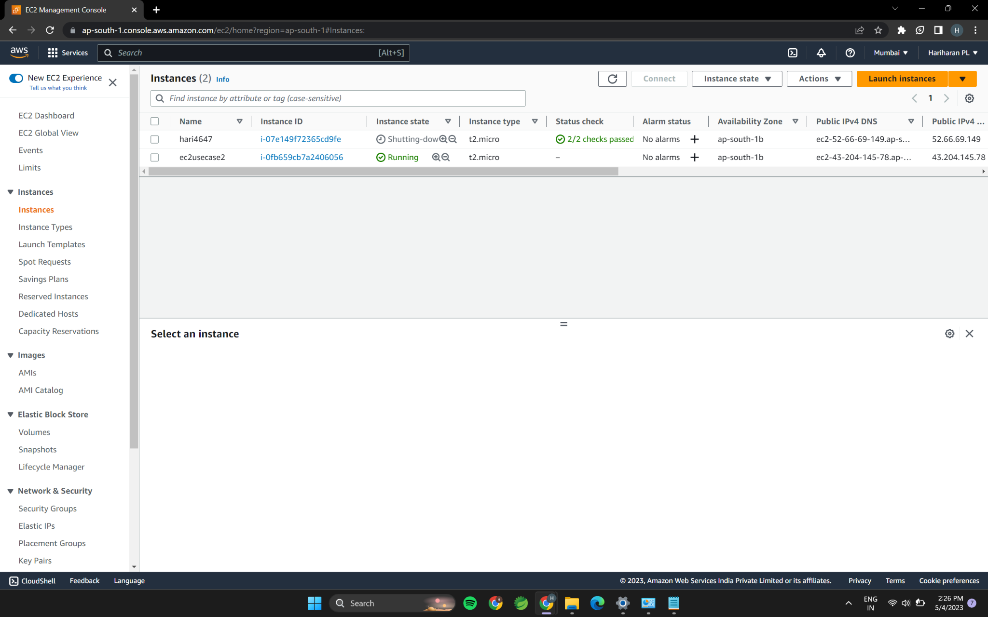

2.Select the AMI from the Amazon Linux OS Platform.

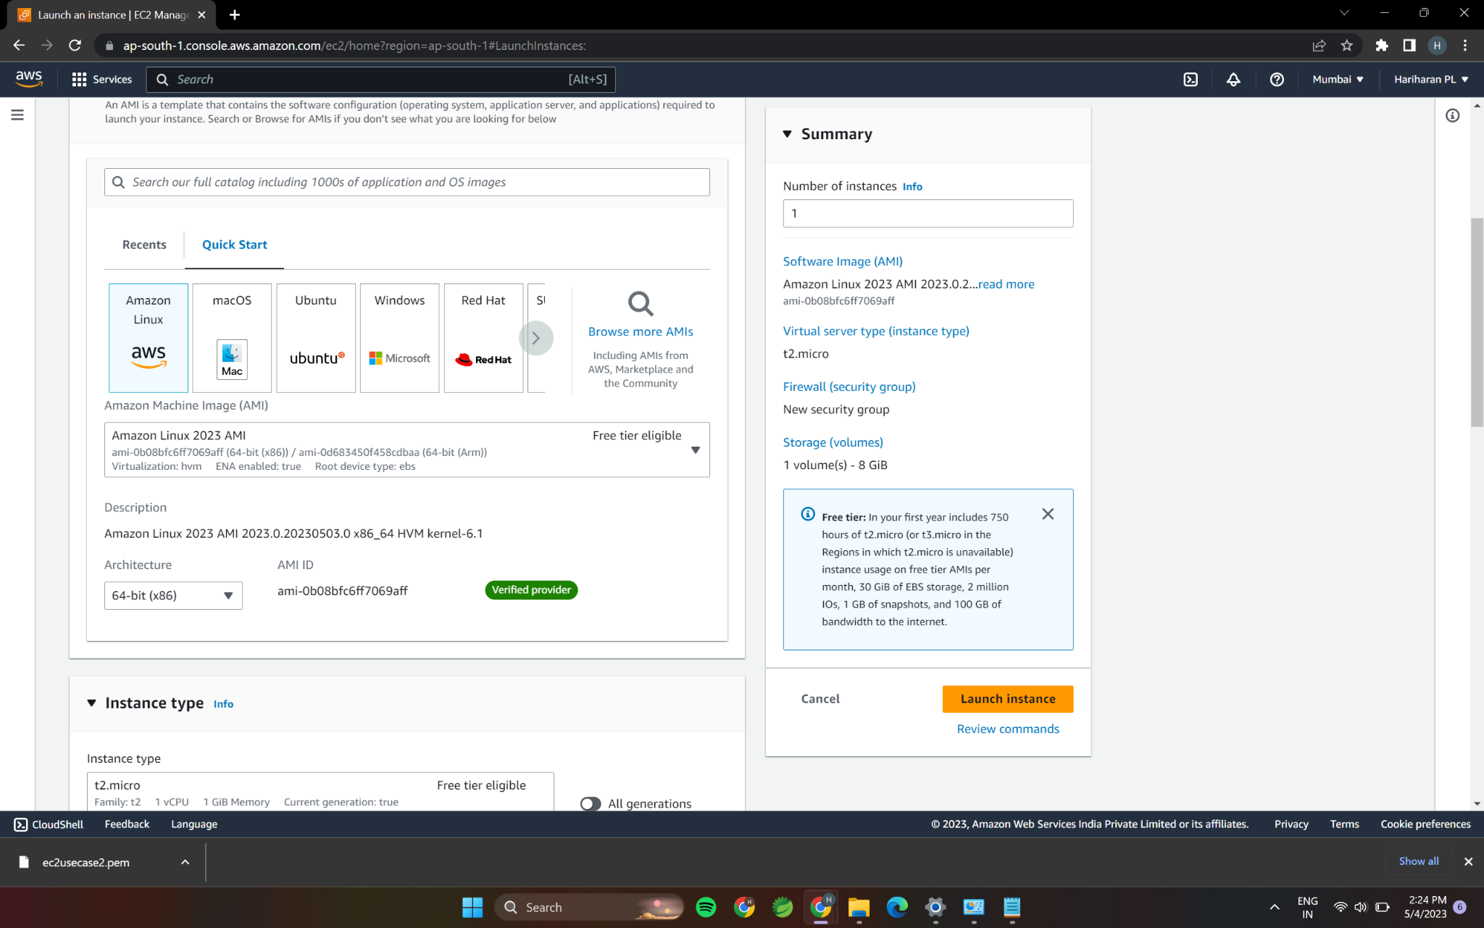

3.Increase the root EBS volume size to 10 GB from the default size.

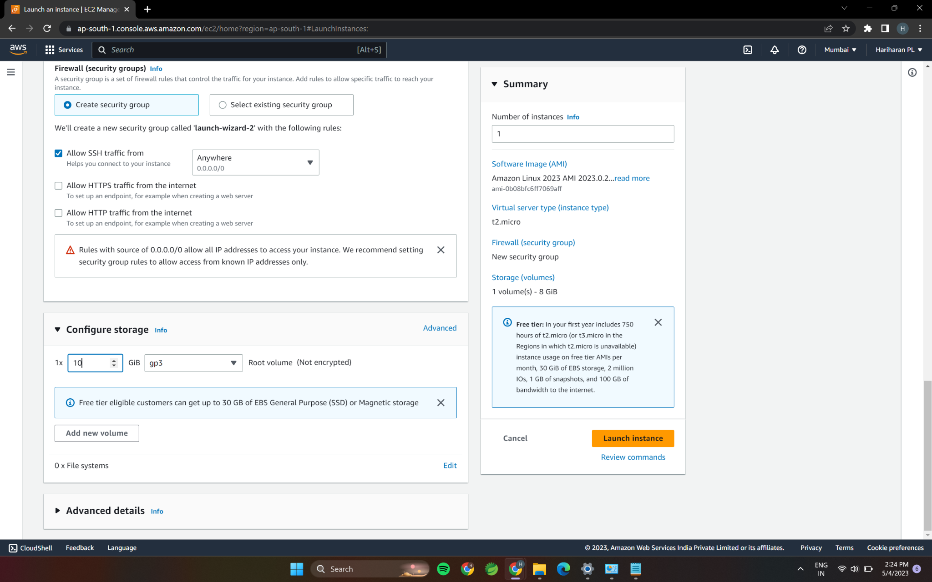

4.Expose Port No.22 for taking putty remote connection.

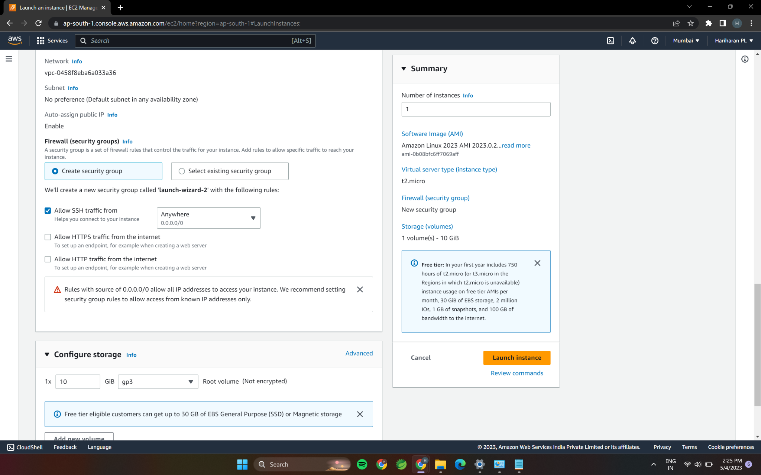

Q2.Create an EC2 Instance in the given AWS account with the following requirements.

1.Give the Name tag of both server & keypair as “ec2usecase2”

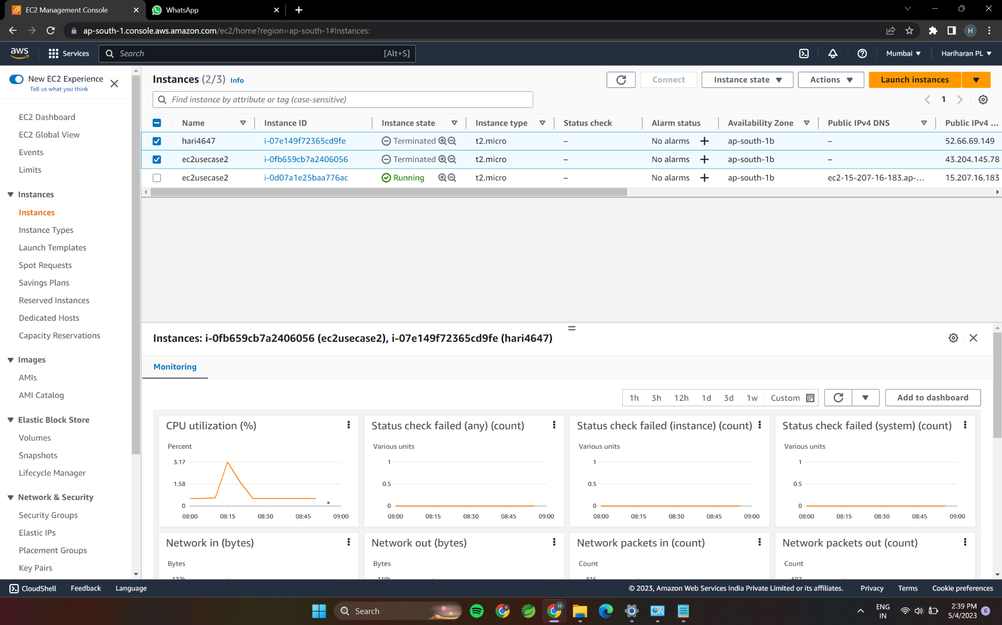

2.Select the AMI from the windows OS Platform.

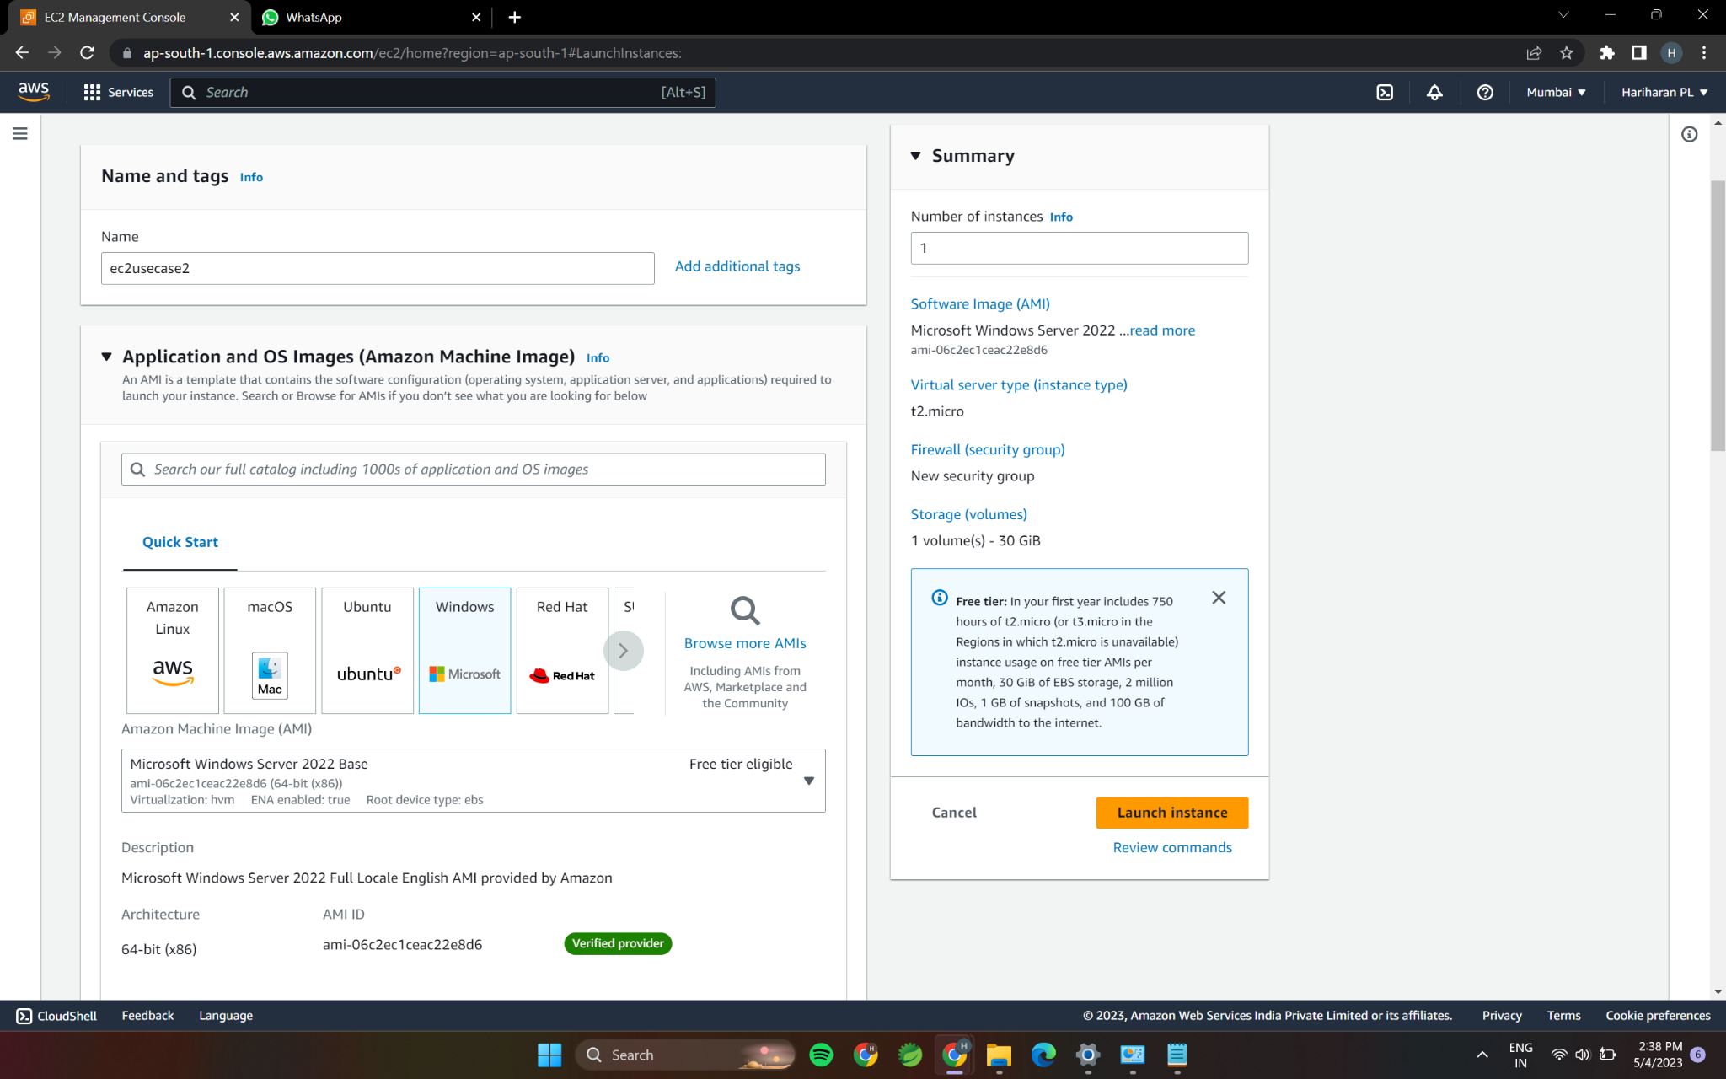

3.Ensure the Auto-Assigned Public-IP must be enabled.

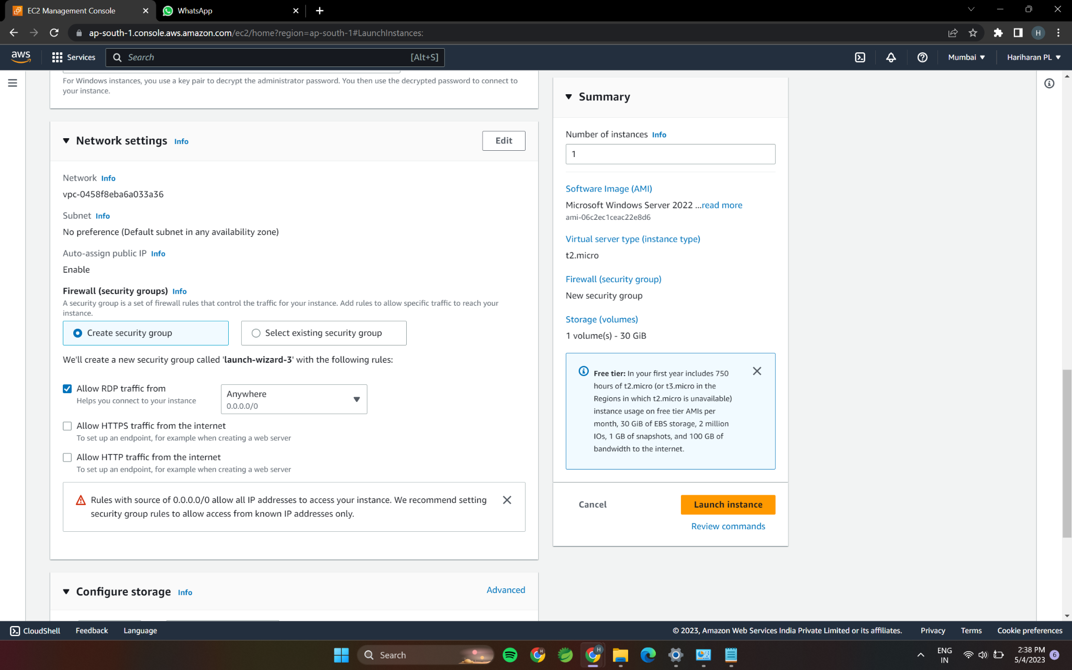

4.Expose Port NO.3389 for taking remote desktop connection.

